**CENTRE FOR DEVELOPMENT OF ADVANCED COMPUTING**



**Advanced Computing Training School**

**Course Name:** PG Diploma in Advanced Computing

**Batch:** March 2022

**Module Name: SDM (set 3) Date: _____________**

**Student Name: _____________________________ Max Marks: 40 Marks**

**PRN No: ___________________________________ Duration: 2 Hours**

**_________________________________________________________________________________**

Q.1: Northwind is a multinational company has their 9 Offshore development centers all over world. They required to build and host Intranet Portal for their employees to access Human Resource, Accounting, Project Management related information.They want to deploy business application on public cloud with the help of Platform As A Service. Northwind has public Cloud subscription to use it as Infrastructure as a Service ( I-a-a-S) and Platform As A Service Company wanted to build and host this Information System in public cloud .

Company wanted to build and host this Information System in public cloud

**Steps:**

**(Capture screen shot of each step performed and store it as jpg file for evaluation.)**

1.Login into your github Account using github credentials.

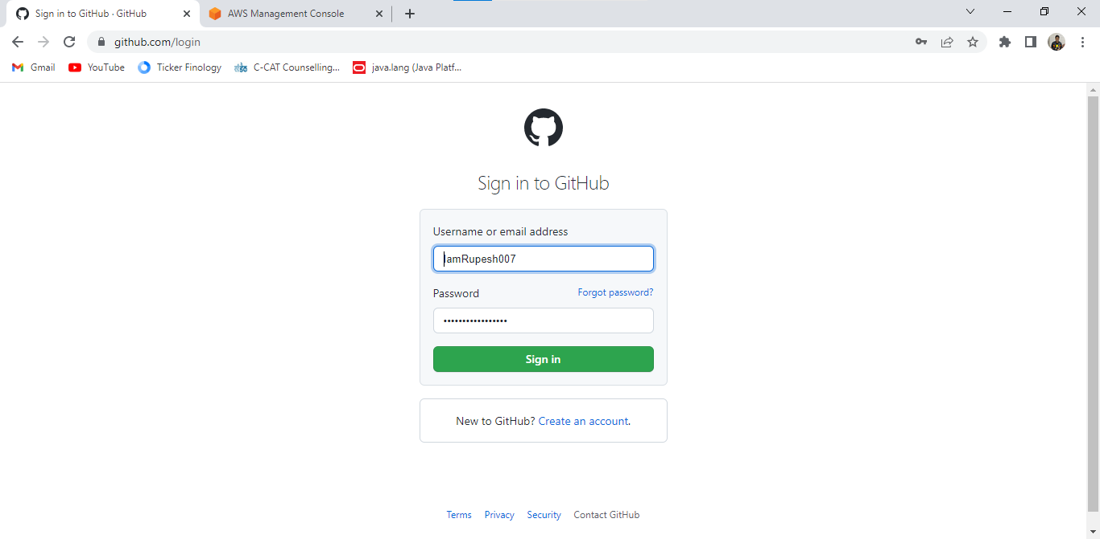

2.Create public git hub repository with name Northwind to your github subscription.

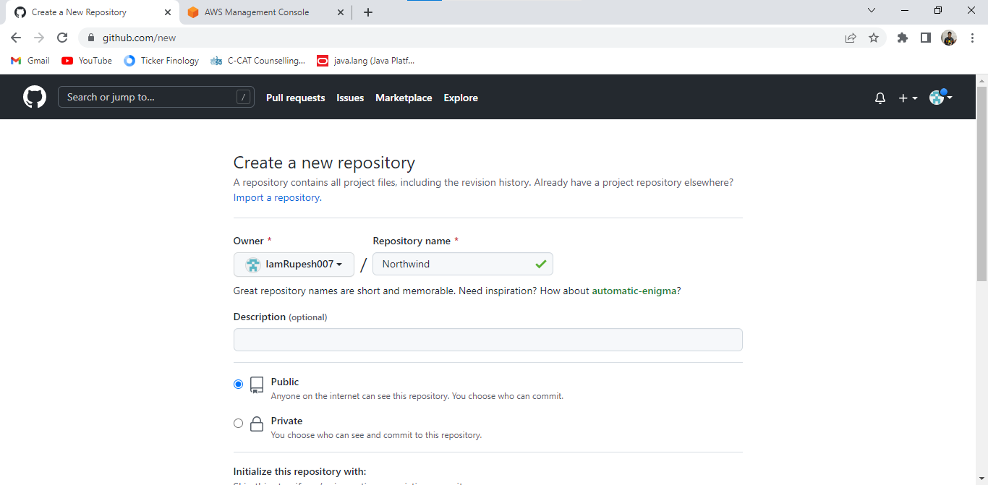

3.Clone GitHub Northwind code repository to your Developer machine using git command.

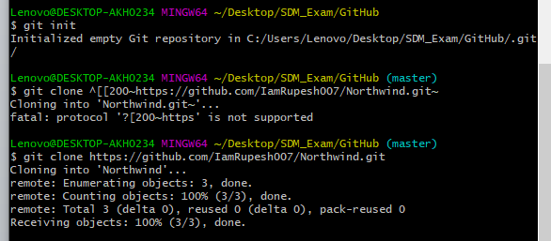

4.Upload Dockerfile, package.json and server.js from local repo to github Northwind repository.

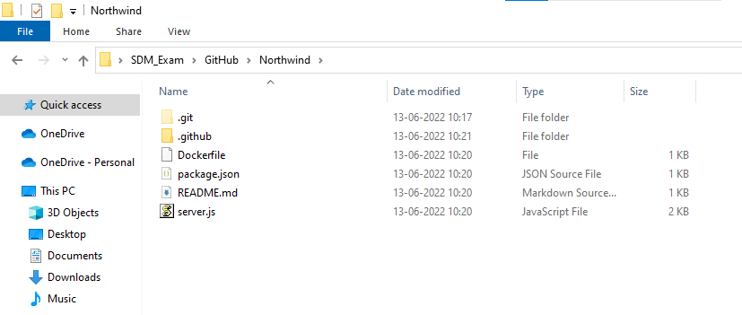

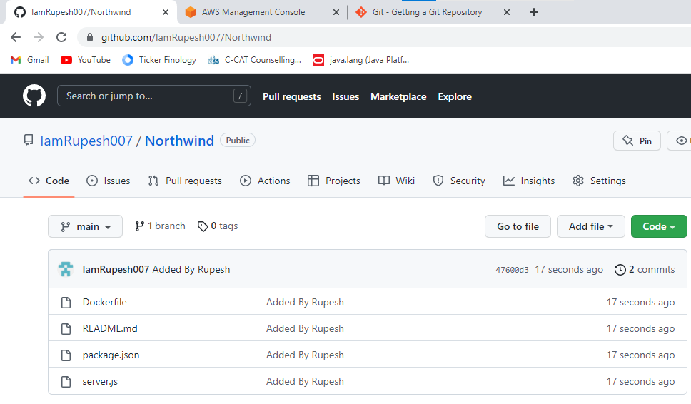

5.Create Linux Amazon Linux Virtual Server using your free trail AWS Subscription.

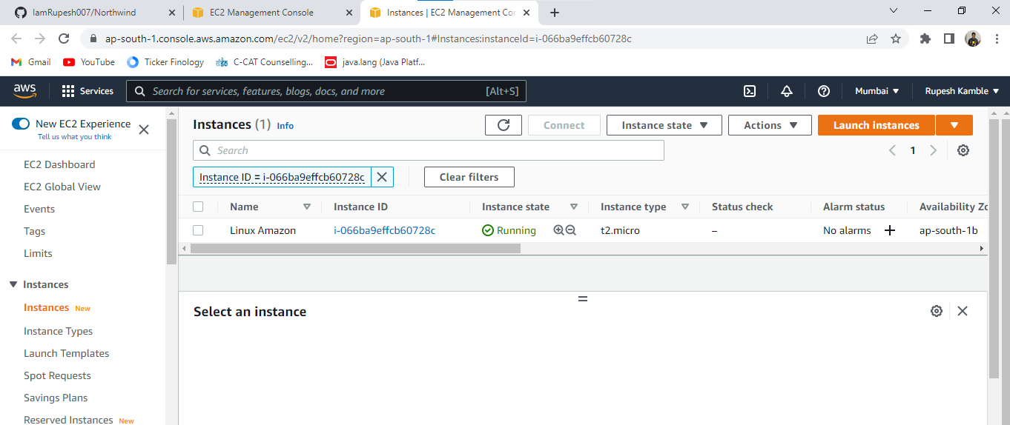

6.Access Virtual Server of Linux created in AWS using Linux Shell ( with the help of putty or Browser connect).

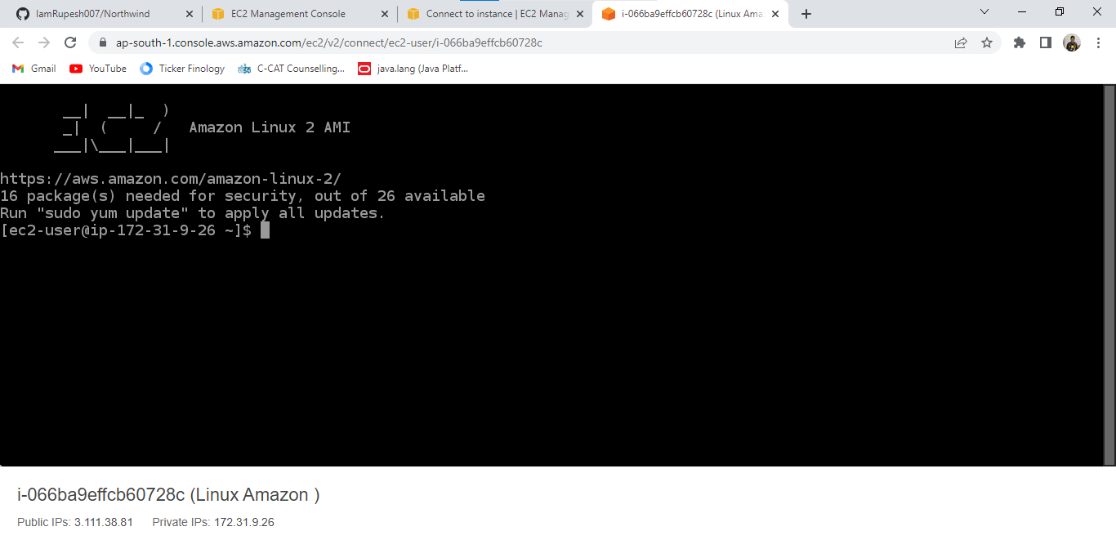

7.Update Linux with latest patches and install Docker in Virtual Server.

sudo update

sudo yum search docker

sudo yum install docker

8.Install git client in Linux Virtual Server.

sudo yum install git

git –version

9.Clone Northwind public code repository to Virual Server.

sudo yum git_path

10.Install Docker to Linux Virtual Server.

install docker

11.Show the status of Docker as running (active).

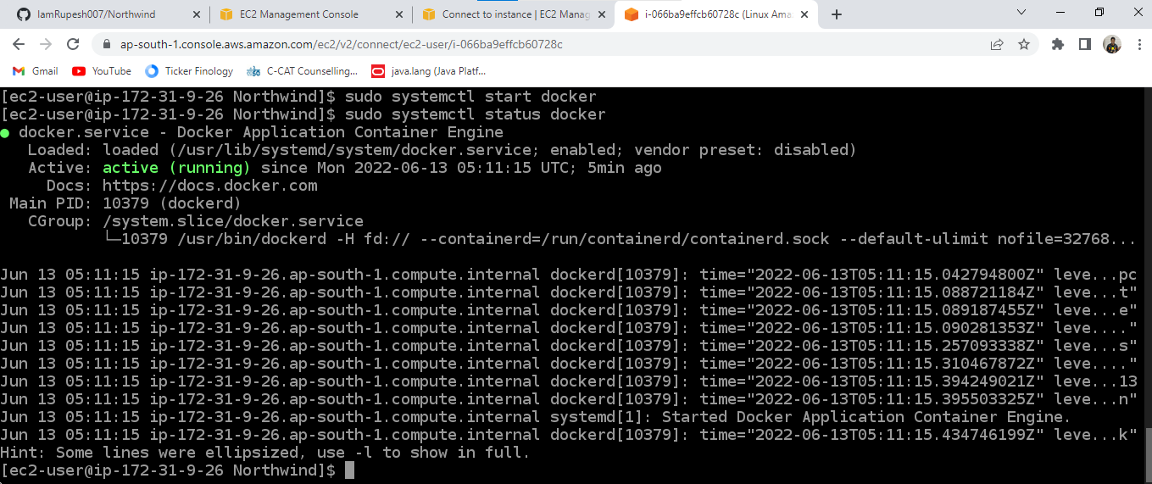

12.Build Docker Container image for Northwind application which is cloned to virtual server.

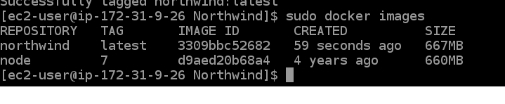

13.Ensure Docker container images are downloaded to Virtual server.

14.Run container instance of Northwind using docker command.



15.List down container instances running using docker on linux virtual server shell.



16.Allow all traffic to be accepted by setting firewall incomming rule.

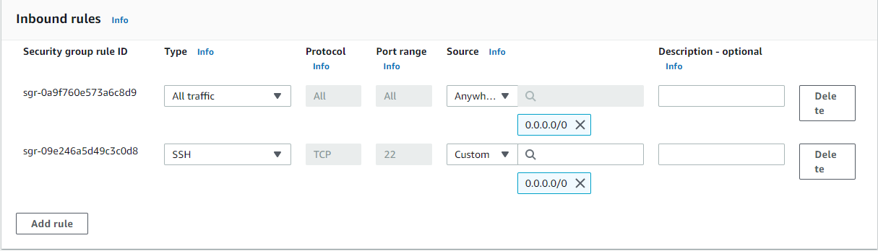

17.Access hosted website using your browser and show page of Website.

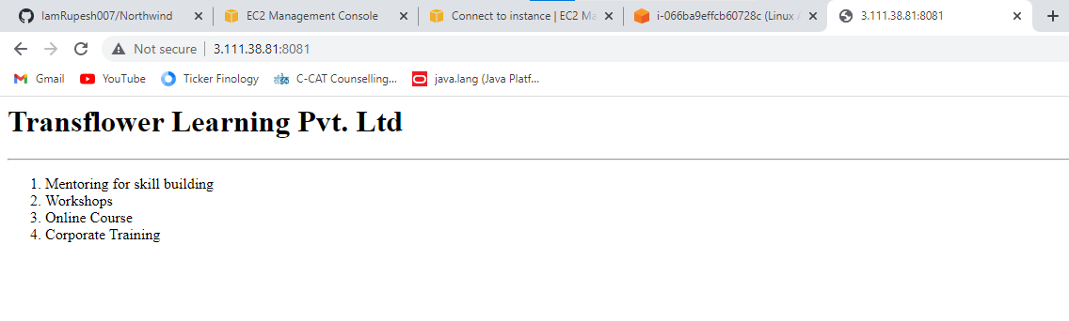

Don't forget to terminate instane once test is over.

Instructions to test Module end exam performance.

Each Point carries equal mark distribution. Last Point 8 will have 3 Marks.

1.Create github repo and pushing server.js, package.json and docker file

2.Creating virutal server with AmazonLinux Operating system and accessing using browser based remote ssh client

3.Installing Docker and checking status of docker running as Active

4.Clonning Public Code repo into Linux Virtual server

5.Build Docker Container Image and list them using Docker Command

6.Run Docker container instanace for clonned repository and List container instance using Docker Command.

7.Set Firewall inbound rule

8.Access Website remotely from Instructors Machine.

_____________________ _________________________ __________________

**Signature of Student** **Signature of Evaluator** **Signature of Coordinator**

**Page 1 of 1**